# Guided Capstone Project Report

Big Mountain Resort actual price is $81.00

Modelled price is $98.07, even with the expected mean absolute error of $10.46, this suggests there is room for an increase.

The validity of our model lies in the assumption that other resorts accurately set their prices according to what the market (the ticket-buying public) supports. The fact that our resort seems to be charging that much less that what's predicted suggests our resort might be undercharging. But if ours is mispricing itself, are others? It's reasonable to expect that some resorts will be "overpriced" and some "underpriced." Or if resorts are pretty good at pricing strategies, it could be that our model is simply lacking some key data? Certainly, we know nothing about operating costs, for example, and they would surely help.

Features that came up as important in the modeling (not just our final, random forest model) included:

5.8.1 Ticket price

Look at where Big Mountain sits overall amongst all resorts for price and for just other resorts in Montana.

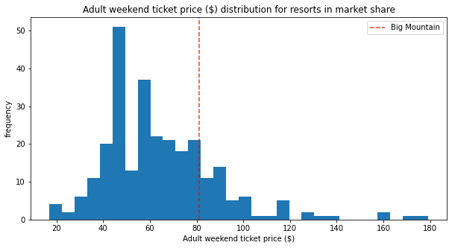

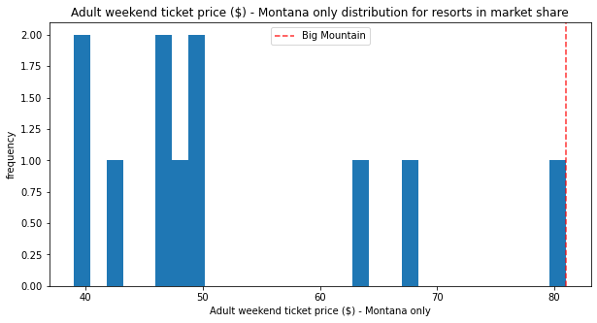

5.8.2 Vertical drop

Big Mountain is doing well for vertical drop, but there are still quite a few resorts with a greater drop.

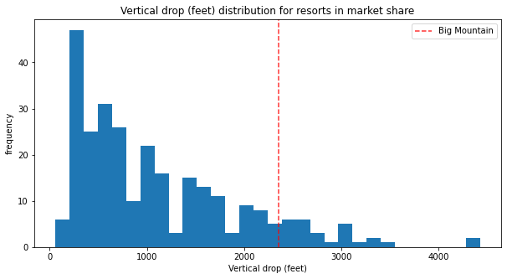

5.8.3 Snow making area

Big Mountain is very high up the league table of snow making area.

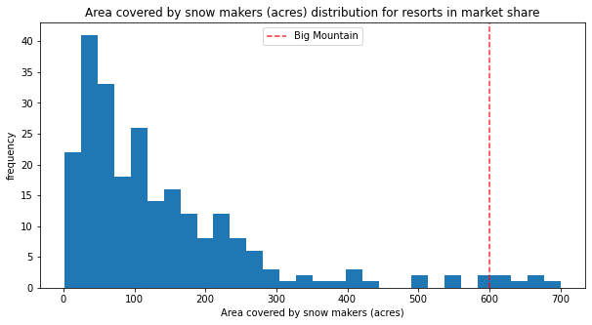

5.8.4 Total number of chairs

Big Mountain has amongst the highest number of total chairs, resorts with more appear to be outliers.

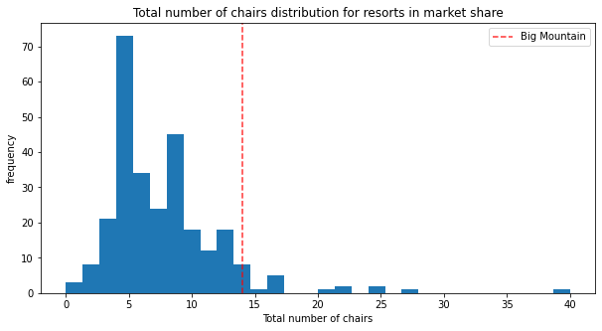

5.8.5 Fast quads

Most resorts have no fast quads. Big Mountain has 3, which puts it high up that league table. There are some values much higher, but they are rare.

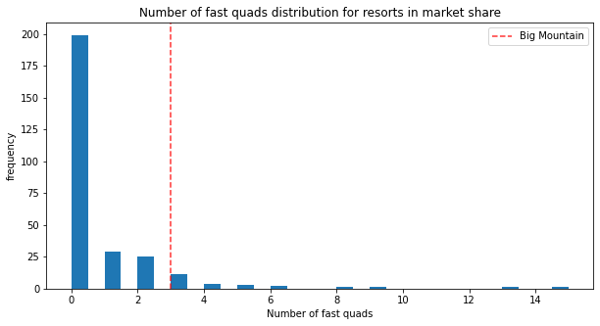

5.8.6 Runs

Big Mountain compares well for the number of runs. There are some resorts with more, but not many.

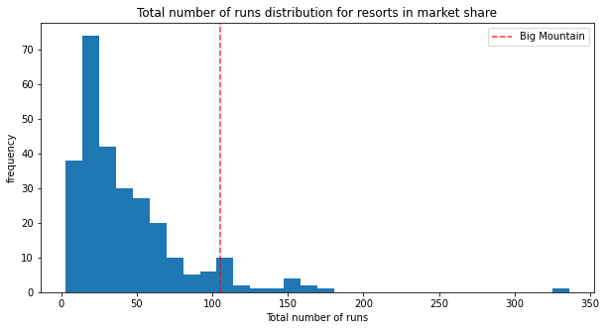

5.8.7 Longest run

Big Mountain has one of the longest runs. Although it is just over half the length of the longest, the longer ones are rare.

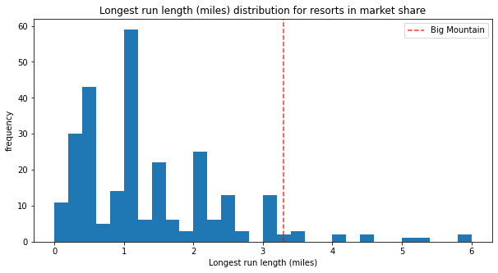

5.8.8 Trams

The vast majority of resorts, such as Big Mountain, have no trams.

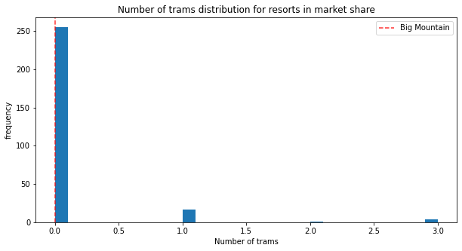

5.8.9 Skiable terrain area

Big Mountain is amongst the resorts with the largest amount of skiable terrain.

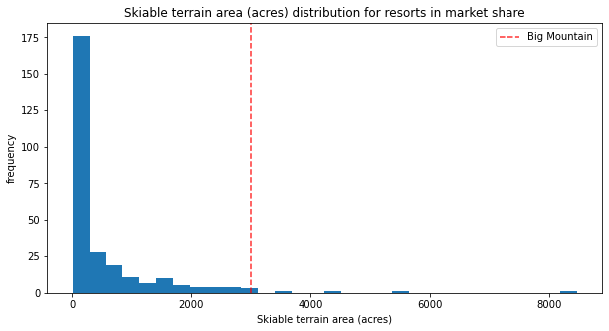

4 Possible Scenarios:

5.9.1 Scenario 1

Close up to 10 of the least used runs. The number of runs is the only parameter varying.

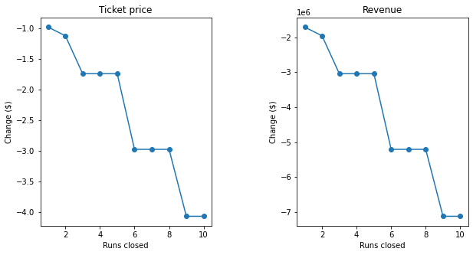

The model says closing one run makes no difference. Closing 2 and 3 successively reduces support for ticket price and so revenue. If Big Mountain closes down 3 runs, it seems they may as well close down 4 or 5 as there's no further loss in ticket price. Increasing the closures down to 6 or more leads to a large drop.

5.9.2 Scenario 2

In this scenario, Big Mountain is adding a run, increasing the vertical drop by 150 feet, and installing an additional chair lift.

This scenario increases support for ticket price by $1.55

Over the season, this could be expected to amount to $2’708,333

5.9.3 Scenario 3

In this scenario, you are repeating the previous one but adding 2 acres of snow making.

This scenario increases support for ticket price by $1.55

Over the season, this could be expected to amount to $2708333

Such a small increase in the snow making area makes no difference!

5.9.4 Scenario 4

This scenario calls for increasing the longest run by .2 miles and guaranteeing its snow coverage by adding 4 acres of snow making capability.

No difference whatsoever. Although the longest run feature was used in the linear model, the random forest model (the one we chose because of its better performance) only has longest run way down in the feature importance list.